Lab 1: Basic Cisco Device Configuration

Topology Diagram

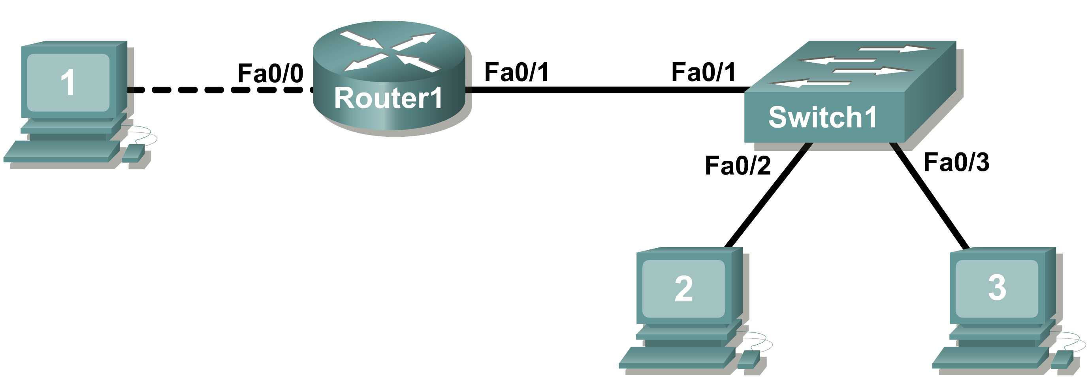

Learning Objectives

- Configure Cisco router global configuration settings.
- Configure Cisco router password access.
- Configure Cisco router interfaces.
- Save the router configuration file.
- Configure a Cisco switch.

Background

Hardware | Qty | Description
Cisco Router | 1 | Part of CCNA Lab bundle.
Cisco Switch | 1 | Part of CCNA Lab bundle.
*Computer (host) | 1 | Lab computer.
Console (rollover) cable | 1 | Connects computer host 1 to Router console port.
UTP Cat 5 crossover cable | 1 | Connects computer host 1 to Router LAN interface Fa0/0
Straight Through Cable | 3 | Connects computer hosts to Switch and switch to router
Table 1. Equipment and hardware required for this lab.

Gather the necessary equipment and cables. To configure the lab, make sure the equipment listed in Table 1 is available.

Common configuration tasks include setting the hostname, access passwords, and MOTD banner.

Interface configuration is extremely important. In addition to assigning a Layer 3 IP address, enter a description that describes the destination connection speeds troubleshooting time.

Configuration changes are effective immediately.

Configuration changes must be saved in NVRAM to be persistent across reboot.

Configuration changes may also be saved off-line in a text file for auditing or device replacement.

Cisco IOS switch configuration is similar to Cisco IOS router configuration.

Scenario

In this lab students will configure common settings on a Cisco Router and Cisco Switch.

Given an IP address of 198.133.219.0/24, with 4 bits borrowed for subnets, fill in the following information in the table below.
(Hint: fill in the subnet number, then the host address. Address information will be easy to compute with the subnet number filled in first)

Maximum number of usable subnets: ______16_________

Number of usable hosts per subnet: ________14___________

 | IP Address: |  | Subnet mask:
# | Subnet | First host address | Last host address | Broadcast
0 | 198.133.219.0 | 198.133.219.1 | 198.133.219.14 | 198.133.219.15
1 | 198.133.219.16 | 198.133.219.17 | 198.133.219.30 | 198.133.219.31

Before proceeding, verify your addresses with the instructor. The instructor will assign subnetworks.

Task 1: Configure Cisco Router Global Configuration Settings.

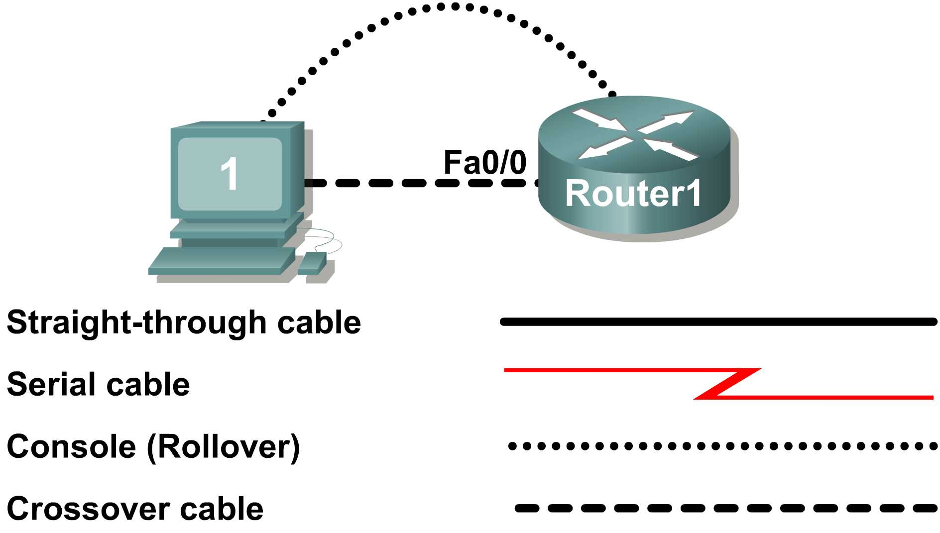
Figure 1. Lab cabling.
Step 1: Physically connect devices.
Refer to Figure 1. Connect the console or rollover cable to the console port on the router. Connect the other end of the cable to the host computer using a DB-9 or DB-25 adapter to the COM 1 port. Connect the crossover cable between the host computer’s network interface card (NIC) and Router interface Fa0/0. Connect a straight-through cable between the Router interface Fa0/1 and any of the switch’s interfaces (1-24).

Ensure that power has been applied to the host computer, switch and router.
Step 2: Connect host computer to router through HyperTerminal.

From the Widows taskbar, start the HyperTerminal program by clicking on Start | Programs | Accessories | Communications | HyperTerminal.

Configure HyperTerminal with the proper settings:

Connection Description

Name: Lab 11_2_11

Icon: Personal choice

Connect to

Connect Using: COM1 (or appropriate COM port)

COM1 Properties

Bits per second: 9600

Data bits: 8

Parity: None

Stop bits: 1

Flow Control: None

When the HyperTerminal session window comes up, press the Enter key until there is a response from the router.

If the router terminal is in the configuration mode, exit by typing NO.

Would you like to enter the initial configuration dialog? [yes/no]: no

Press RETURN to get started!

Router>

From the user exec mode, enter privileged exec mode:

Router> enable

Router#

Verify a clean configuration file with the privileged exec command show running-config. If a configuration file was previously saved, it will have to be removed. Appendix 1 shows a typical default router’s configuration. Depending on router’s model and IOS version, your configuration may look slightly different. However, there should be no configured passwords or IP addresses. If your router does not have a default configuration, ask the instructor to remove the configuration.

Step 3: Configure global configuration hostname setting.

From the privileged exec mode, enter global configuration mode:

Router# configuration terminal -> conf terminal

Router(config)#

What three commands may be used to leave the global configuration mode and return to the privileged exec mode?

___________________________________________________________________________________

___________________________________________________________________________________

What shortcut command can be used to enter the global configuration mode? ______________________

Set the device hostname to Router1:

router(config)# hostname Router1

Router1(config)#

How can the hostname be removed?

___________________________________________________________________________________

Step 4: Configure the MOTD banner.

In production networks, banner content may have a significant legal impact on the organization. For example, a friendly “Welcome” message may be interpreted by a court that an attacker has been granted permission to hack into the router. A banner should include information about authorization, penalties for unauthorized access, connection logging, and applicable local laws. The corporate security policy should provide policy on all banner messages.

Router1(config)# banner ?

Configure the MOTD banner. The MOTD banner is displayed on all connections before the login prompt. Use the terminating character on a blank line to end the MOTD entry:

Router1(config)# banner motd %

Enter TEXT message. End with the character '%'

***You are connected to an ABC network device. Access is granted to only current ABC company system administrators with prior written approval. ***

*** Unauthorized access is prohibited, and will be prosecuted. ***

*** All connections are continuously logged. ***

%

Router1(config)#

What is the global configuration command to remove the MOTD banner?

___________________________________________________________________________________
Task 2: Configure Cisco router password access.

Access passwords are set for the privileged exec mode and user entry point such as console, aux, and virtual lines. The privileged exec mode password is the most critical password, since it controls access to the configuration mode.

Step 1: Configure the privileged exec password.

Cisco IOS supports two commands that set access to the privileged exec mode. One command, enable password, contains weak cryptography and should never be used if the enable secret command is available. The enable secret command uses a very secure MD5 cryptographic hash algorithm. Cisco says “As far as anyone at Cisco knows, it is impossible to recover an enable secret based on the contents of a configuration file (other than by obvious dictionary attacks).” Password security relies on the password algorithm, and the password. . In production environments, strong passwords should be used at all times. A strong password consists of at least nine characters of upper and lower case letters, numbers, and symbols. In a lab environment, we will use weak passwords.

Set the privileged exec password to cisco.

Router1(config)# enable secret cisco

Router1(config)#
Step 2: Configure the console password.

Set the console access password to class. The console password controls console access to the router.

Router1(config)# line console 0

Router1(config-line)# password class

Router1(config-line)# login

What is the command to remove the console password? _____________________________
Step 3: Configure the virtual line password.

Set the virtual line access password to class. The virtual line password controls Telnet access to the router. In early Cisco IOS versions, only five virtual lines could be set, 0 through 4. In newer Cisco IOS versions, the number has been expanded. Unless a telnet password is set, access on that virtual line is blocked.

Router1(config-line)# line vty 0 4

Router1(config-line)# password class

Router1(config-line)# login

There are three commands that may be used to exit the line configuration mode:

Command | Effect
 | Return to the global configuration mode.
 | Exit configuration and return to the privileged exec mode.

Issue the command exit. What is the router prompt? What is the mode?

Router1(config-line)# exit

___________________________________________________________________________________

___________________________________________________________________________________

Issue the command end. What is the router prompt? What is the mode?

___________________________________________________________________________________

Task 3: Configure Cisco Router Interfaces.

All cabled interfaces should contain documentation about the connection. On newer Cisco IOS versions, the maximum description is 240 characters.

Figure 2. Physical lab topology.

Figure 2 shows a network topology where a host computer is connected to Router1, interface Fa0/0.

Write down your subnet number and mask: ________________________________________________

The first IP address will be used to configure the host computer LAN. Write down the first IP Address:

___________________________________________________________________________________

The last IP address will be used to configure the router fa0/0 interface. Write down the last IP Address:

___________________________________________________________________________________
Step 1: Configure the router fa0/0 interface.

Write a short description for the connections on Router1:

Fa0/0 ->

___________________________________________________________________________________

Apply the description on the router interface with the interface configuration command, description:

Router1(config)# interface fa0/0

Router1(config-if)# description Connection to Host1 with crossover cable

Router1(config-if)# ip address 192.133.219.14 255.255.255.240 (nhanh mang 1, hang so 1 trong anh: muon 4 bit mang con-> .240)

Router1(config-if)# no shutdown

Router1(config-if)# end

Router1#

Look for the interface to become active:
*Mar 24 19:58:59.602: %LINEPROTO-5-UPDOWN: Line protocol on Interface FastEthernet0/0, changed state to up
Step 2: Configure the router Fa0/1 interface.

Write a short description for the connections on Router1:

Fa0/1 ->

___________________________________________________________________________________

Apply the description on the router interface with the interface configuration command, description:

Router1(config)# interface fa0/1

Router1(config-if)# description Connection to switch with straight-through cable

Router1(config-if)# ip address 192.133.219.30 255.255.255.240

Router1(config-if)# no shutdown

Router1(config-if)# end

Router1#

Look for the interface to become active:
*Mar 24 19:58:59.602: %LINEPROTO-5-UPDOWN: Line protocol on Interface FastEthernet0/1, changed state to up
Step 3: Configure the host computer.

Configure the host computer for LAN connectivity. Recall that the LAN configuration window is accessed through Start | Control Panel | Network Connections. Right-click on the LAN icon, and select Properties. Highlight the Internet Protocol field, and select Properties. Fill in the following fields:

IP Address: The first host address __________________________

Subnet Mask: The subnet mask ____________________________

Default Gateway: Router’s IP Address _______________________

Click OK, and then Close. Open a terminal window, and verify network settings with the ipconfig command.
Step 4: Verify network connectivity.

Use the ping command to verify network connectivity with the router. If ping replies are not successful troubleshoot the connection:

What Cisco IOS command can be used to verify the interface status? __________________________

What Windows command can be used to verify host computer configuration? _____________________

What is the correct LAN cable between host1 and Router1? _______________________________
Task 4: Save the Router Configuration File.

Cisco IOS refers to RAM configuration storage as running-configuration, and NVRAM configuration storage as startup-configuration. For configurations to survive rebooting or power restarts, the RAM configuration must be copied into non-volatile RAM (NVRAM). This does not occur automatically, NVRAM must be manually updated after any changes are made.
Step 1: Compare router RAM and NVRAM configurations.

Use the Cisco IOS show command to view RAM and NVRAM configurations. The configuration is displayed one screen at a time. A line containing “ -- more -- “ indicates that there is additional information to display. The following list describes acceptable key responses:

Key | Description
<SPACE> | Display the next page.
<RETURN> | Display the next line.
Q | Quit
<CTRL> c | Quit

Write down one possible shortcut command that will display the contents of NVRAM.

Display the contents of NVRAM. If the output of NVRAM is missing, it is because there is no saved configuration.:

Router1# show startup-config

startup-config is not present

Router1#

Display the contents of RAM.

Router1#show running-config

Use the output to answer the following questions:

How large is the configuration file? ____________________

What is the enable secret password? ________________________

Does your MOTD banner contain the information you entered earlier? __________________________

Do your interface descriptions contain the information you entered earlier? ____________________

Write down one possible shortcut command that will display the contents of RAM. _________________
Step 2: Save RAM configuration to NVRAM.

For a configuration to be used the next time the router is powered on or reloaded, it must be manually saved in NVRAM. Save the RAM configuration to NVRAM:

Router1# copy running-config startup-config

Destination filename [startup-config]? <ENTER>

Building configuration...

[OK]

Router1#

Write down one possible shortcut command that will copy the RAM configuration to NVRAM.

____________________________

Review the contents of NVRAM, and verify that the configuration is the same as the configuration in RAM.
Task 5: Configure a Cisco Switch.
Cisco IOS switch configuration is (thankfully) similar to configuring a Cisco IOS router. The benefit of learning IOS commands is that they are similar to many different devices and IOS versions.
Step 1: Connect the host to the switch.
Move the console, or rollover, cable to the console port on the switch. Ensure power has been applied to the switch. In Hyperterminal, press Enter until the switch responds.
Step 2. Configure global configuration hostname setting.

Appendix 2 shows a typical default switch configuration. Depending on router model and IOS version, your configuration may look slightly different. However, there should be no configured passwords. If your router does not have a default configuration, ask the instructor to remove the configuration.

From the user exec mode, enter global configuration mode:

Switch> en

Switch# config t

Switch(config)#

Set the device hostname to Switch1.

Switch(config)# hostname Switch1

Switch1(config)#
Step 3: Configure the MOTD banner.

Create a suitable MOTD banner. Only system administrators of the ABC company are authorized access, unauthorized access will be prosecuted, and all connection information will be logged.

Configure the MOTD banner. The MOTD banner is displayed on all connections before the login prompt. Use the terminating character on a blank line to end the MOTD entry. For assistance, review the similar step for configuring a router MOTD banner.

Switch1(config)# banner motd %
Step 4: Configure the privileged exec password.

Set the privileged exec password to cisco.

Switch1(config)# enable secret cisco

Switch1(config)#
Step 5: Configure the console password.

Set the console access password to class.

Switch1(config)# line console 0

Switch1(config-line)# password class

Switch1(config-line)# login
Step 6: Configure the virtual line password.

Set the virtual line access password to class. There are 16 virtual lines that can be configured on a Cisco IOS switch, 0 through 15.

Switch1(config-line)# line vty 0 15

Switch1(config-line)# password class

Switch1(config-line)# login

Figure 3. Network topology.

Step 7: Configure the interface description.

Figure 3 shows a network topology where Router1 is connected to Switch1, interface Fa0/1. Switch1 interface Fa0/2 is connected to host computer 2, and interface Fa0/3 is connected to host computer 3.

Write a short description for the connections on Switch1:

Router1 Interface | Description

Fa0/1

Fa0/2

Fa0/3

Apply the descriptions on the switch interface with the interface configuration command, description:

Exit => config

Switch1(config)# interface fa0/1

Switch1(config-if)# description Connection to Router1

Switch1(config)# interface fa0/2

Switch1(config-if)# description Connection to host computer 2

Switch1(config)# interface fa0/3

Switch1(config-if)# description Connection to host computer 3

Switch1(config-if)# end

Switch1#
Step 8: Save RAM configuration to NVRAM.

For a configuration to be used the next time the switch is powered on or reloaded, it must be manually saved in NVRAM. Save the RAM configuration to NVRAM:

Switch1# copy run start

Destination filename [startup-config]? <ENTER>

Building configuration...

[OK]

Switch1#

Review the contents of NVRAM, and verify that the configuration is the same as the configuration in RAM.
Task 6: Reflection
The more you practice the commands, the faster you will become in configuring a Cisco IOS router and switch. It is perfectly acceptable to use notes at first to help configure a device, but a professional network engineer does not need a ‘cheat sheet’ to perform common configuration tasks. The following table lists commands covered in this lab:

Purpose | Command
Enter the global configuration mode. | configure terminal  Example:  Router> enable  Router# configure terminal  Router(config)#
Specify the name for the router. | hostname name  Example:  Router(config)# hostname Router1  Router(config)#
Specify an encrypted password to prevent unauthorized access to the privileged exec mode. | enable secret password  Example:  Router(config)# enable secret cisco  Router(config)#
Specify a password to prevent unauthorized access to the console. | password password  login  Example:  Router(config)# line con 0  Router(config-line)# password class  Router(config-line)# login  Router(config)#
Specify a password to prevent unauthorized telnet access.  Router vty lines: 0 4  Switch vty lines: 0 15 | password password  login  Example:  Router(config)# line vty 0 4  Router(config-line)# password class  Router(config-line)# login  Router(config-line)#
Configure the MOTD banner. | Banner motd %  Example:  Router(config)# banner motd %  Router(config)#
Configure an interface.  Router- interface is OFF by default  Switch- interface is ON by default | Example:  Router(config)# interface fa0/0 Router(config-if)# description description  Router(config-if)# ip address address mask  Router(config-if)# no shutdown  Router(config-if)#
Save the configuration to NVRAM. | copy running-config startup-config  Example:  Router# copy running-config startup-config  Router#

Task 7: Challenge

It is often necessary, and always handy, to save the configuration file to an off-line text file. One way to save the configuration file is to use HyperTerminal Transfer menu option Capture.

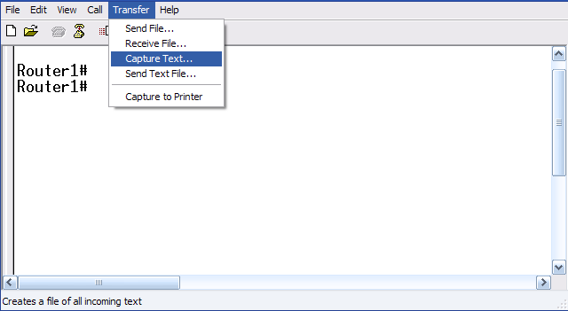

Figure 2. Hyperterminal Capture menu.

Refer to Figure 2. All communication between the host computer and router are saved to a file. The file can be edited, and saved. The file can also be edited, copied, and pasted into a router:

To start a capture, select Hyperterminal menu option Transfer | Capture Text. Enter a path and file name, and select Start.

Issue the privileged exec command show running-config, and press the <SPACE> key until all of the configuration has been displayed.

Stop the capture. Select menu option Transfer | Capture Text | Stop.

Open the text file and review the contents. Remove any lines that are not configuration commands, such as the more prompt. Manually correct any lines that were scrambled or occupy the same line. After checking the configuration file, highlight the lines and select Notepad menu Edit | Copy. This places the configuration in host computer memory.

To load the configuration file, it is ALWAYS best practice to begin with a clean RAM configuration. Otherwise, stale configuration commands may survive a paste action and have unintended consequences (also known as the Law of Unintended Consequences):

Erase the NVRAM configuration file:

Router1# erase start
Erasing the nvram filesystem will remove all configuration files! Continue? [confirm] <ENTER>
[OK]
Erase of nvram: complete

Reload the router:

Router1# reload
Proceed with reload? [confirm] <ENTER>

When the router reboots, enter the global configuration mode:

Router> en
Router# config t
Router(config)#

Using the mouse, right-click inside the Hyperterminal window and select Paste To Host. The configuration will be loaded, very quickly, to the router. Watch closely for error messages, each message must be investigated and corrected.

Verify the configuration,

Router#show running-config

and save to NVRAM:

Router#copy running-config startup-config
Task 8: Clean Up.
Before turning off power to the router and switch, remove the NVRAM configuration file from each device with the privileged exec command erase startup-config.

Delete any configuration files saved on the host computers.

Unless directed otherwise by the instructor, restore host computer network connectivity, then turn off power to the host computers. Remove anything that was brought into the lab, and leave the room ready for the next class.
Appendix 1- Default Cisco IOS router configuration

Current configuration : 824 bytes
!
version 12.4
service timestamps debug datetime msec
service timestamps log datetime msec
no service password-encryption
!
hostname Router
!
boot-start-marker
boot-end-marker
!
no aaa new-model
ip cef
!
interface FastEthernet0/0
no ip address
shutdown
duplex auto
speed auto
!
interface FastEthernet0/1
no ip address
shutdown
duplex auto
speed auto
!
interface Serial0/1/0
no ip address
shutdown
no fair-queue
!
interface Serial0/1/1
no ip address
shutdown
clock rate 2000000
!
interface Vlan1
no ip address
!
ip http server
no ip http secure-server
!
control-plane
!
line con 0
line aux 0
line vty 0 4
login
!
scheduler allocate 20000 1000
end
Appendix 2- Default Cisco IOS switch configuration

Current configuration : 1519 bytes
!
version 12.1
no service pad
service timestamps debug uptime
service timestamps log uptime
no service password-encryption
!
hostname Switch
!
!
ip subnet-zero
!
!
spanning-tree mode pvst
no spanning-tree optimize bpdu transmission
spanning-tree extend system-id
!
!
interface FastEthernet0/1
no ip address
!
interface FastEthernet0/2
no ip address
!
interface FastEthernet0/3
no ip address
!
interface FastEthernet0/4
no ip address
!
interface FastEthernet0/5
no ip address
!
interface FastEthernet0/6
no ip address
!
interface FastEthernet0/7
no ip address
!
interface FastEthernet0/8
no ip address
!
interface FastEthernet0/9
no ip address
!
interface FastEthernet0/10
no ip address
!
interface FastEthernet0/11
no ip address
!
interface FastEthernet0/12
no ip address
!
interface FastEthernet0/13
no ip address
!
interface FastEthernet0/14
no ip address
!
interface FastEthernet0/15
no ip address
!
interface FastEthernet0/16
no ip address
!
interface FastEthernet0/17
no ip address
!
interface FastEthernet0/18
no ip address
!
interface FastEthernet0/19
no ip address
!
interface FastEthernet0/20
no ip address
!
interface FastEthernet0/21
no ip address
!
interface FastEthernet0/22
no ip address
!
interface FastEthernet0/23
no ip address
!
interface FastEthernet0/24
no ip address
!
interface GigabitEthernet0/1
no ip address
!
interface GigabitEthernet0/2
no ip address
!
interface Vlan1
no ip address
no ip route-cache
shutdown
!
ip http server
!
!
line con 0
line vty 5 15
!
end

